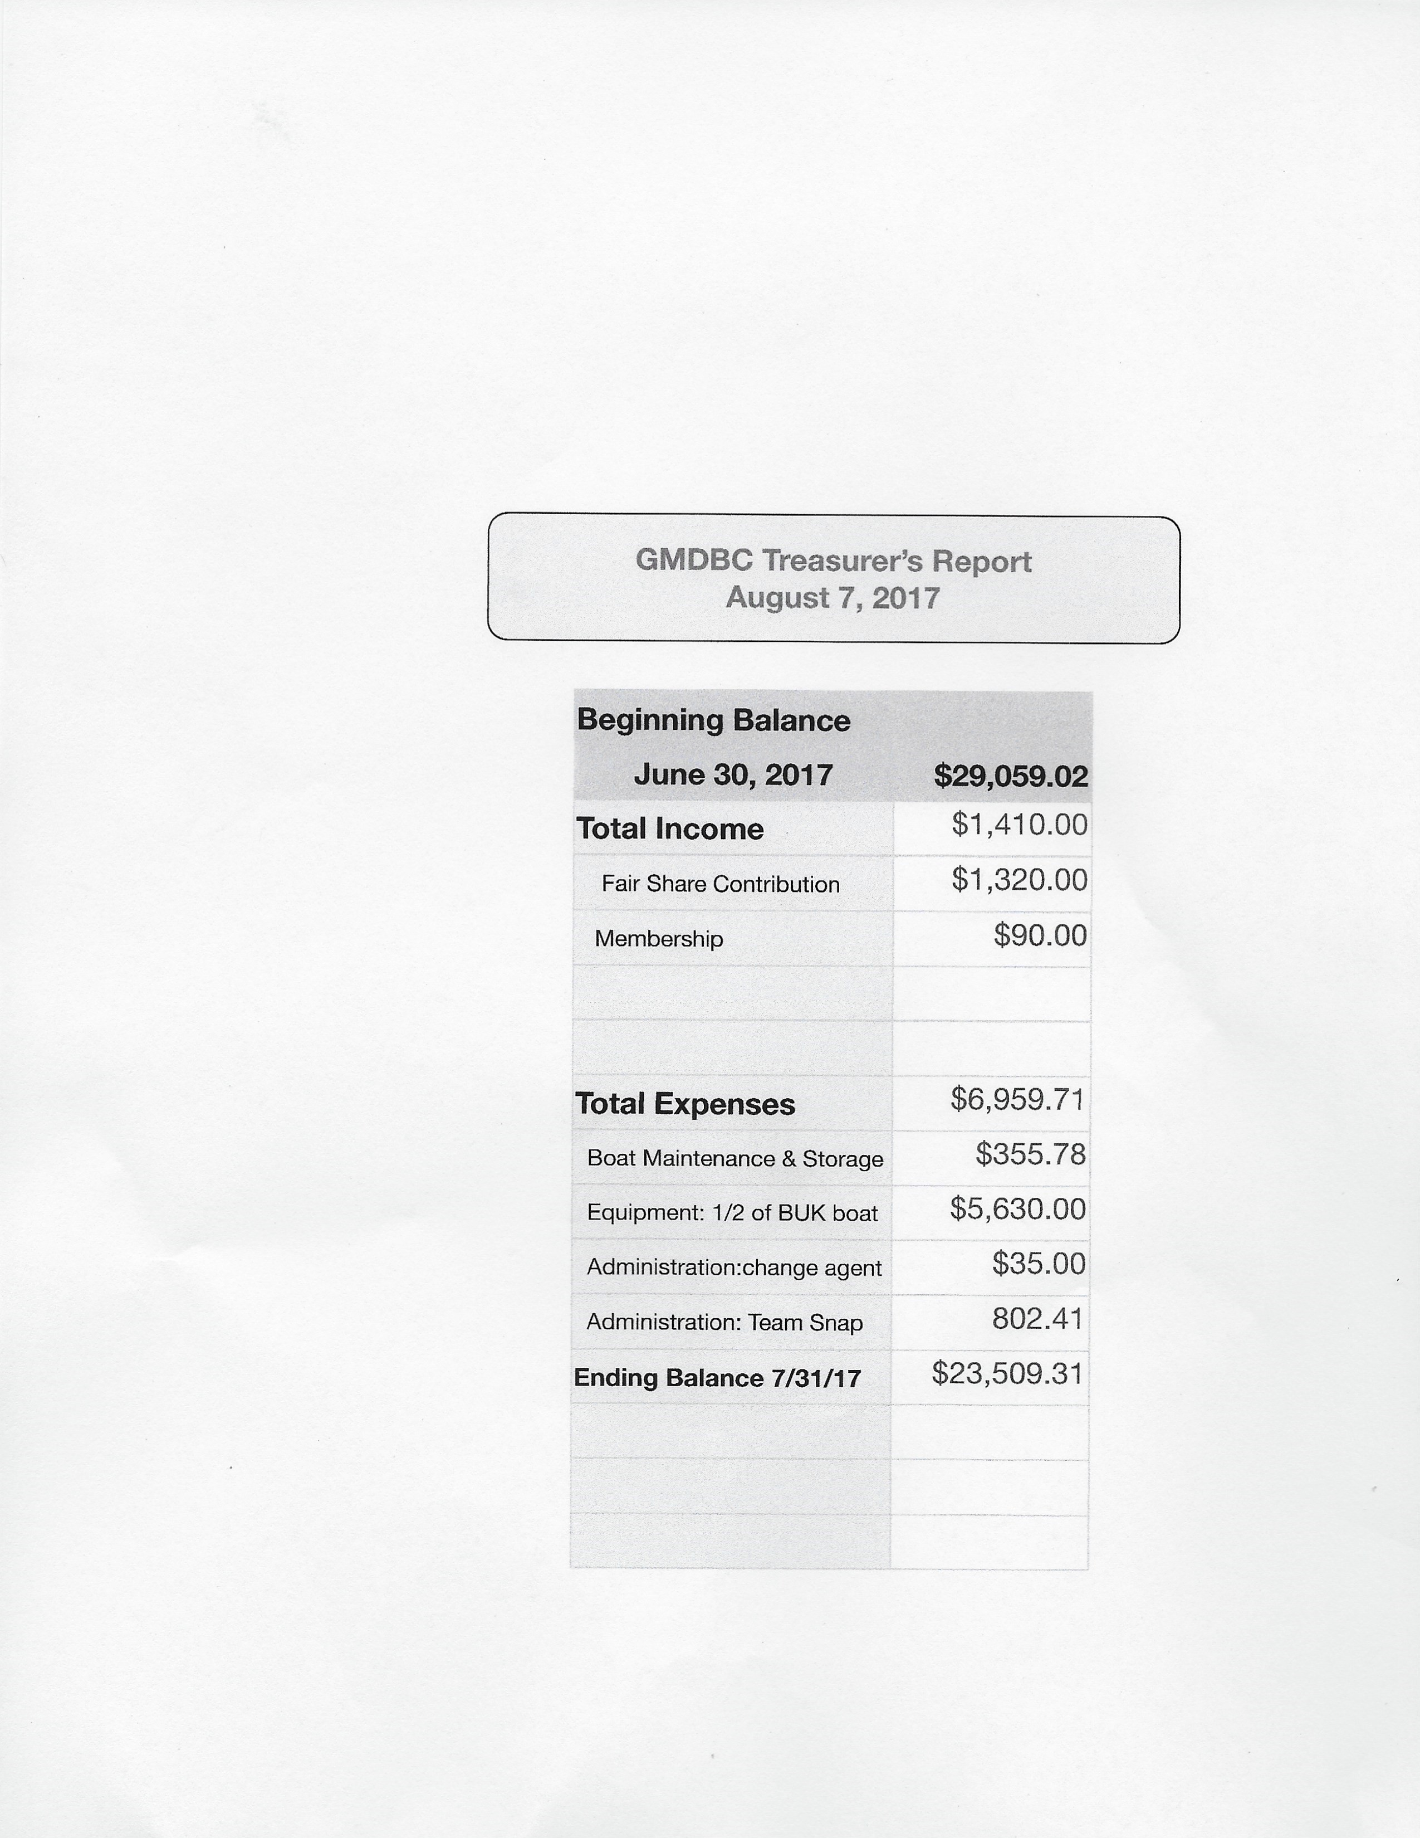

From: RaeAnn Bethel

Subject: GMDBC: treasurer's report for August

Date: Aug 3, 2017, PM

To: Mary Lou Townley jloutownley@gmail.com, Lee Cerovac feesum0777@gmailvcom

Hi John and Lee, I will be in the Bahamas next week and unable to attend the board meeting. May I impose on you to present my report. Attaching: the monthly presentation.

Other topics:

1. Remind teams that their tax report to Rod Tompkins is due August 31.

If they need help... ask Rod or myself. Please thank the teams that have already completed theirs... a couple have... according to Rod.

1. Update on bank signature cards I have filed with SunBiz.org (corporation dept. of the state) to change our registered agent from Cheryl Moran to myself. Form was sent July 28th. Once that change shows on line, I can file to change the officers.... updating to John and Lee.

Once that is done, we can do signature cards at Citizens.

1. Notable expenses this month:

$5,630 - boat deposit 

$802.41 - team snap annual fee

$355.78 - boat maintenance and storage

$136.52 - Camp Villages medals

$35.00 - change of registered agent fee

Oh.... FYI: When I mentioned to Bob Kane the need to ask the board to purchase medals before he orders, he assured me he did when he came to the board and presented his program for Camp Villages.Thanks for handling this for me. RaeAnn