GRAND MASTERS

DRAGON BOAT CLUB INC.

Board Of Directors & Captains

MEETING

Date: 05/13/13 Monday 12:00 PM

Location: Chatham Recreation Center

Call to Order
Vice- resident, Marilyn Hintermeister called the meeting to order at 12:00 PM.

Attendance
# | Position | Name/Team | Status
1 | President | Lee Cerovac | Absent
2 | Vice President | Marilyn Hintermeister | Present
3 | Treasurer | Per Olesen | Present
4 | Secretary | Garf Cooper | Present
5 | Team Captain | Robert Saltsman/Leathernecks | Present
6 | Team Captain | Sue Knox/Patty Flugman/ Dragon Sisters | Present
7 | Team Captain | Gordon Gillis, Christine Gillis Black Sheep Marine | Present
8 | Team Captain | Christine, /Silver Dragons | Present
9 | Team Captain | Don Glass/Leatherneck Warriors | Present
11 | Team Captain | Barbra/Village Dragons | Present
12 | Team Captain | Cynthia Dove/This Boat Rocks Exercise | Present
13 | Team Captain | Cynthia Dove /This Boat Rocks Competitive | Present
13 | Boat Maintenance | Marilyn Hintermeister (for Fred Frederiksen) | Present
14 | Publicity | Pam Frederiksen | Absent

Clinics
BCS form the Sister going to the Tampa

Upcoming Races:
Warren Butts, Webmaster, has provided the capability to list the races for each team to facilitate coordination and capitalization of resources. Captains will need to enter the future races for this effort to work.

May races
Mira bay the GMDBC Womens Team came in 2nd place
May 25 Chattahoochee River

June Races
June 7-9 Montgomery This Boat Rocks, Bus for transportation. Dragon Sisters
June 1 Ricks mad paddle
June 23 Ottaw Canada BlackSheep

July Races

August Races

September
Lake Mercer Sep 15-16 USDBF Nationals
Jacksonville 21 Sep 1013 Leatherneck, Black Sheep, Silver Dragons
Sept 28 St. Peat no teams

OCTOBER
19 October Disney – 5 GMDBCs

November
November 2-3 SRDBA Regional’s coupled with the Veterans Memorial Park Dragon Boat Festival on the by-pass canal in Tampa.
November 16, 2013 Ricks mad Paddle

IDBF Worlds:
Lee briefed the Captains reference
Age – limit for Senior C has been published as 60 -70 GMDBC is challenging the upper limit. Fourteen Men from GMDBC have the OK to go to Hungary.

Treasures Report
Per Olesen, Treasurer, reported 239 members, Bank balance of $5353.68

GMDBC Officers Election
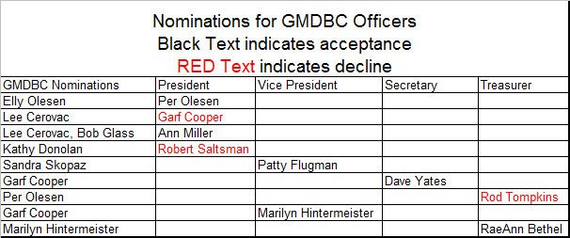

Old Business Items
- There is a desire for a larger Club Banner to support fund raises in the future.
Marilyn will have a price on a large banner
Cost range under $200.00
New design for the larger club banner Barbra Bickley
“Grand Masters Dragon Boat Club”
Fabric – vinyl with hemmed edges
Size – 8 ft by 2 ft
Design – same as the existing banner, hemmed with grommets for the crew flags to be hung from the banner.
In July Barbra will have a price for this new banner.
- The red boat is in repair estimate is $2052.00. Pricing for the repairs is growing by $800.00. Fred is working closely with the repair Contractor to manage the effort.
- The Sheriffs department coordination POC organizing the Youth Team startup wants to wait until the end of the year to start this event.
- GMDBC Team Committee Ann Miller, reported on Basic Paddler Training Program, items covered include:
  - New Paddlers Packet
  - Need packets back from the Captains to build team profiles for the packet
  - Personal Profile
  - Training Outline – four weeks
    - Ground school
    - Pool side paddling
    - Boat training
  - Transition to a competitive team.
- BOD and budget meeting is planned for June 10, 2013 at Chatham Recreation Center.

New Business:
- At the Tampa races, there was a mistake during a race and the Villages Dragons complained to the organizer PAN AM. The PAN AM steersman stopped the boat 50 meters before the finish line. He thought he was at the finish line. There was no resolution!
What if anything should the club do in this situation?
- At the Marathon races, a paddler observed a steersperson who was obviously drinking. During the race, the boat he was steering lost control.
What if anything should the club do in this situation?

Members News
No members news was discussed

Closing
The meeting ended at 1:20 PM
The next BOD/Captains meeting is scheduled for 06/10/2012 at Chatham Recreation Center 12:00 PM

Minutes Submitted by Garf Cooper, Secretary

